Day 19 - Challenge03

- Launch oneEC2 instance using Amazon Linux 2.
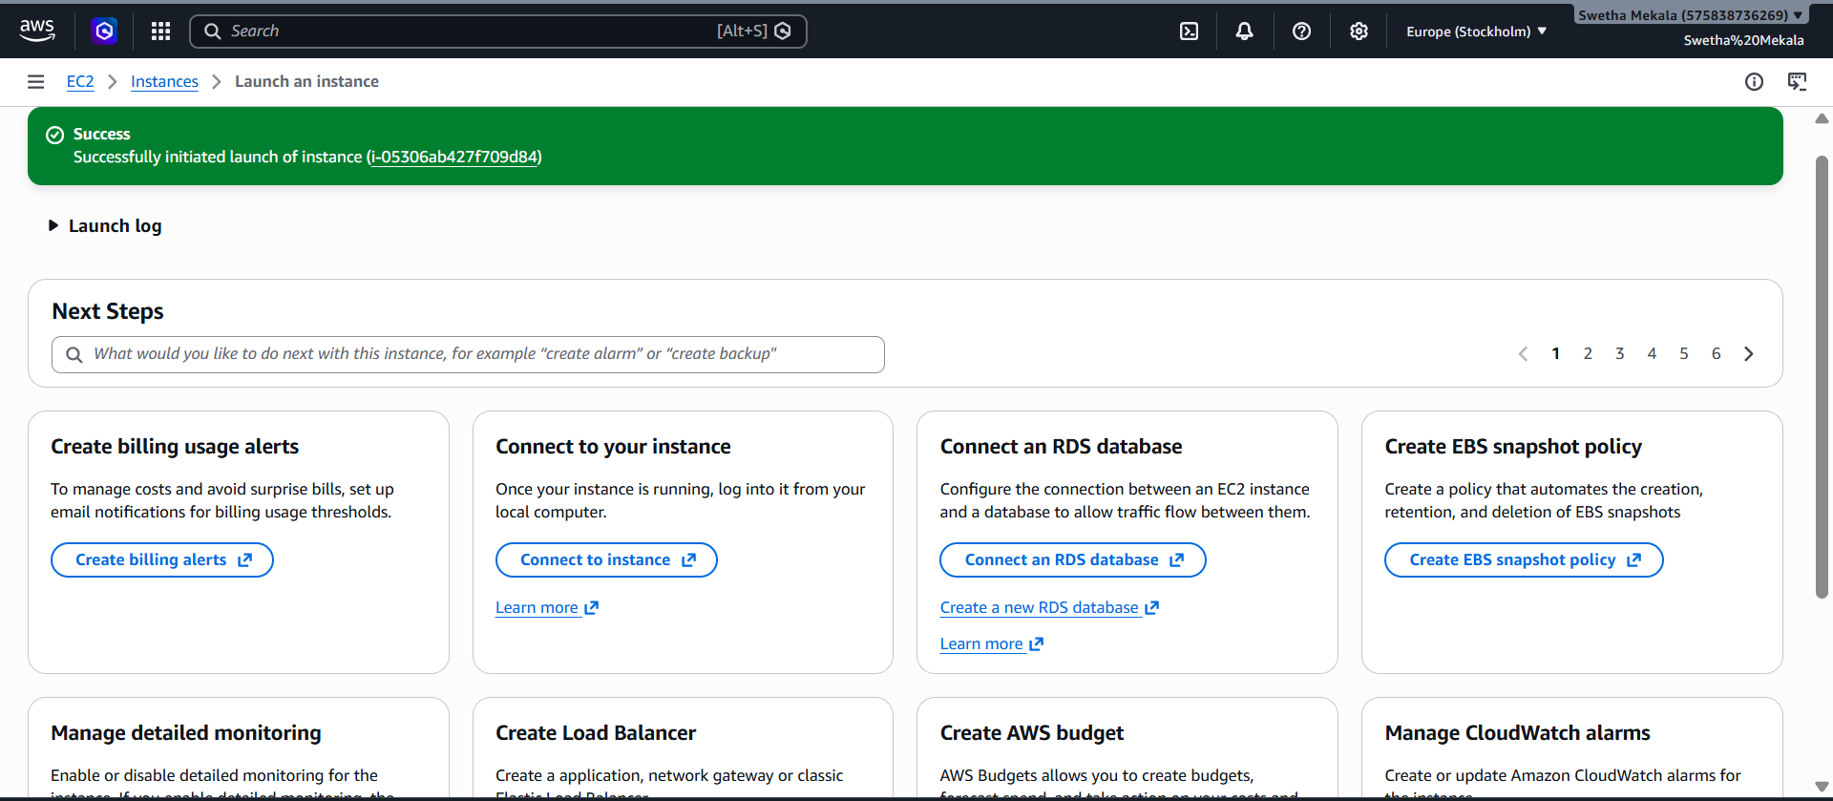

- Install Docker.
- sudo yum update -y
- sudo dnf install docker -y
- sudo systemctl start docker
- sudo systemctl enable docker
- sudo systemctl status docker
- docker –version
- sudo docker run hello-world
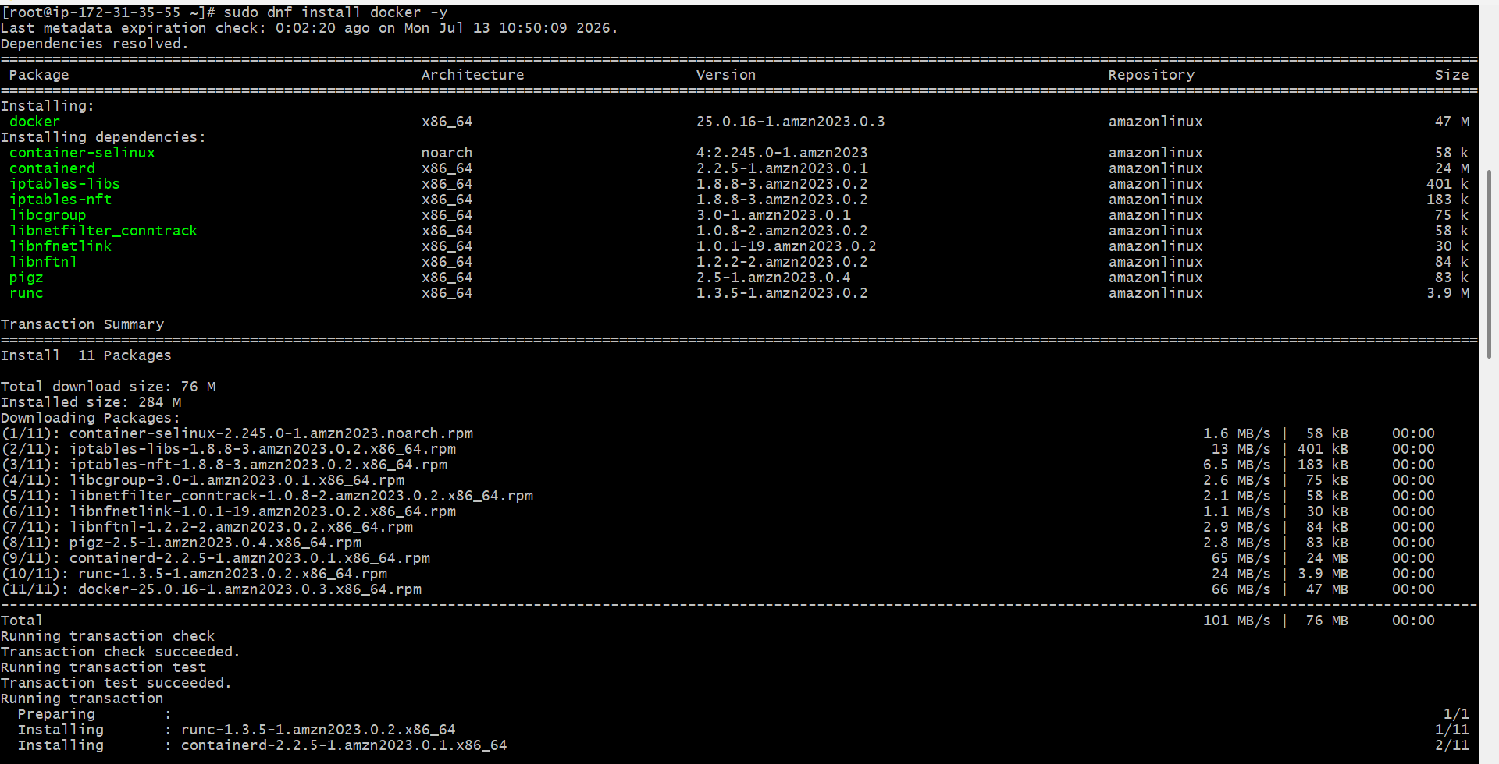

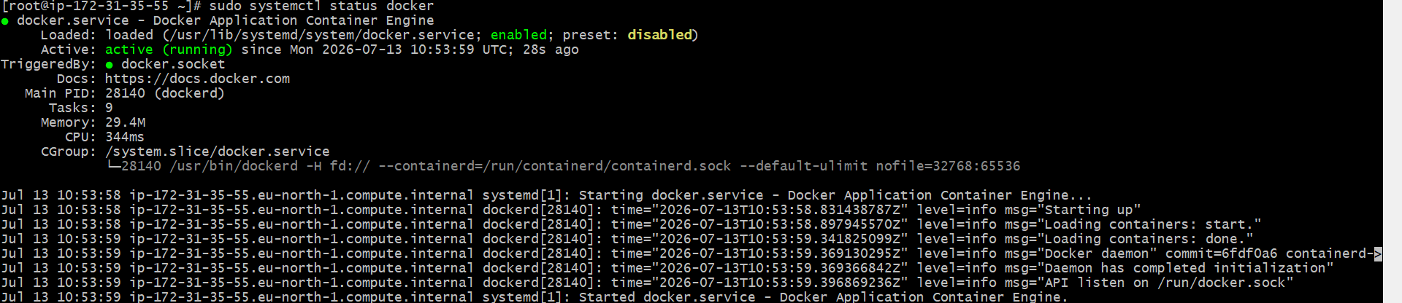
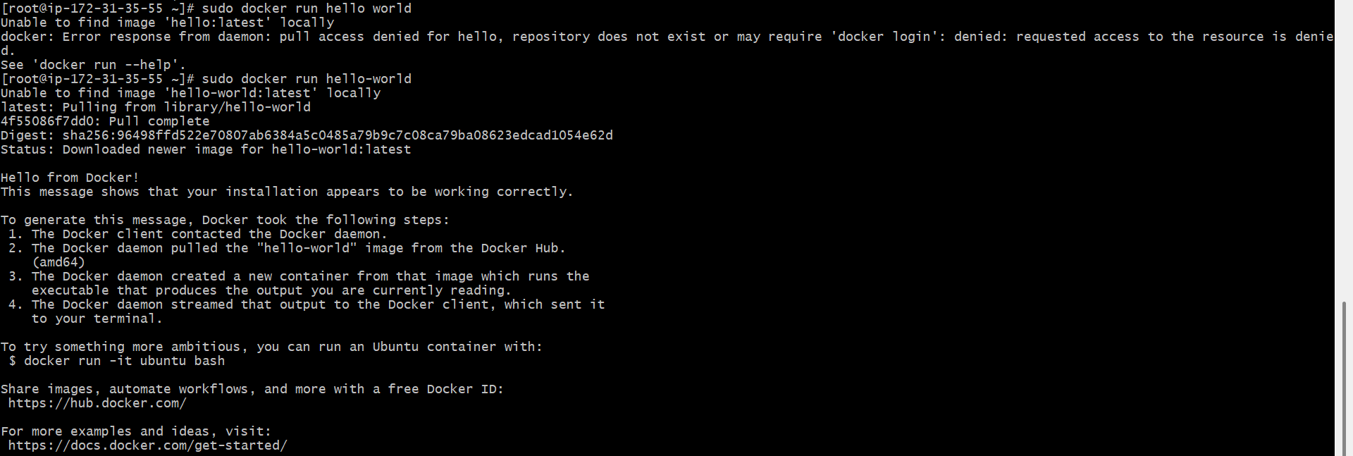
3. Install Jenkins
- sudo dnf update -y
- sudo dnf install java-21-amazon-corretto -y
- java -version
- Add the Jenkins repository - sudo wget -O /etc/yum.repos.d/jenkins.repo https://pkg.jenkins.io/redhat-stable/jenkins.repo
- sudo rpm --import https://pkg.jenkins.io/redhat-stable/jenkins.io-2023.key
- sudo dnf install jenkins -y
- sudo systemctl start Jenkins
- sudo systemctl enable Jenkins
- sudo systemctl status Jenkins
- Get the initial administrator password from - sudo cat /var/lib/jenkins/secrets/initialAdminPassword -> e38970c723db4832a399a3dfbe6eb23d
- Open http://13.48.136.64:8080/ on you browser, then you’ll see the Jenkins server up and running.
- Unlock your server with the password, Install all the required packages and the server will be ready to use.
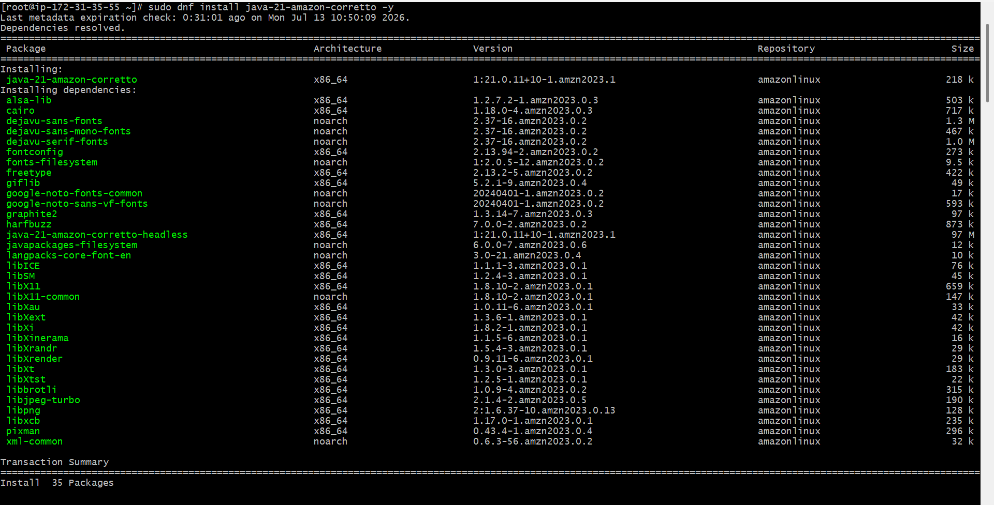
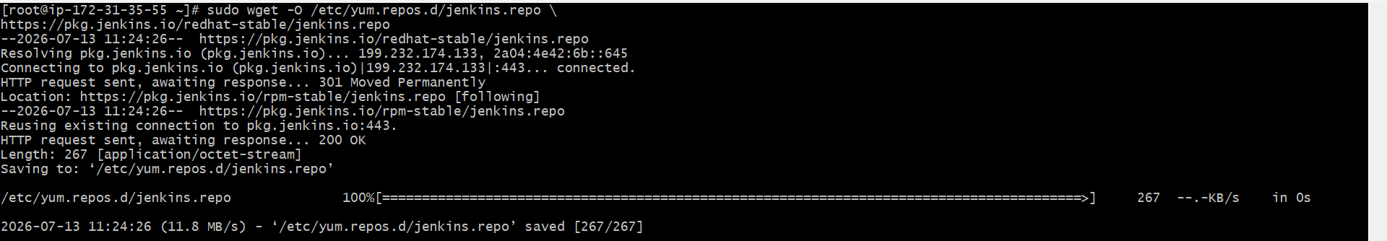
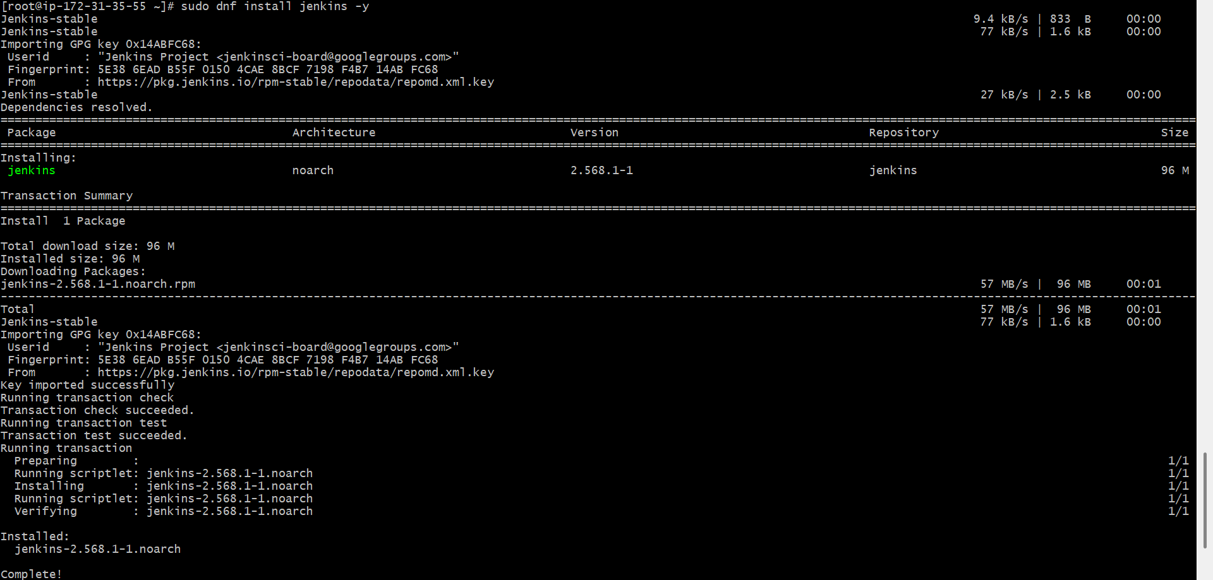
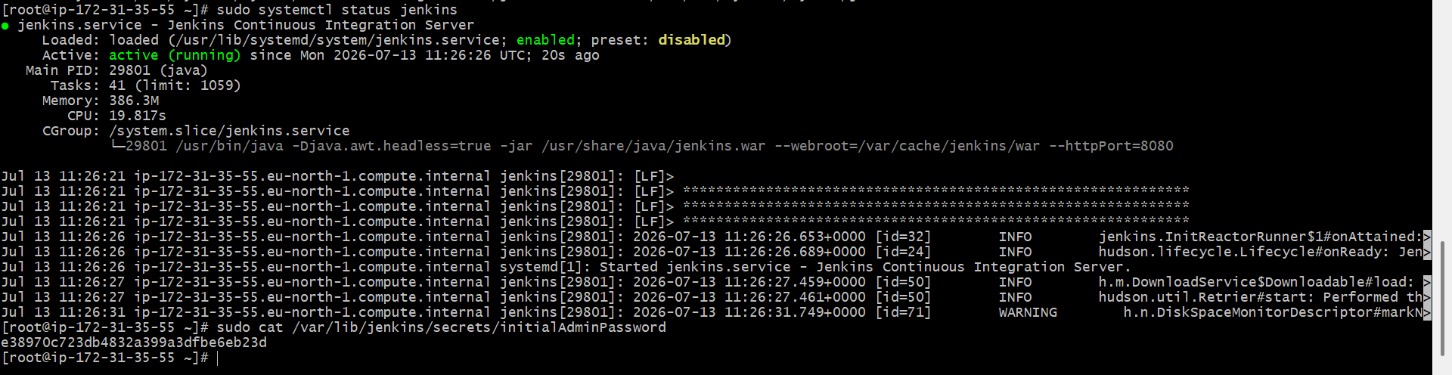
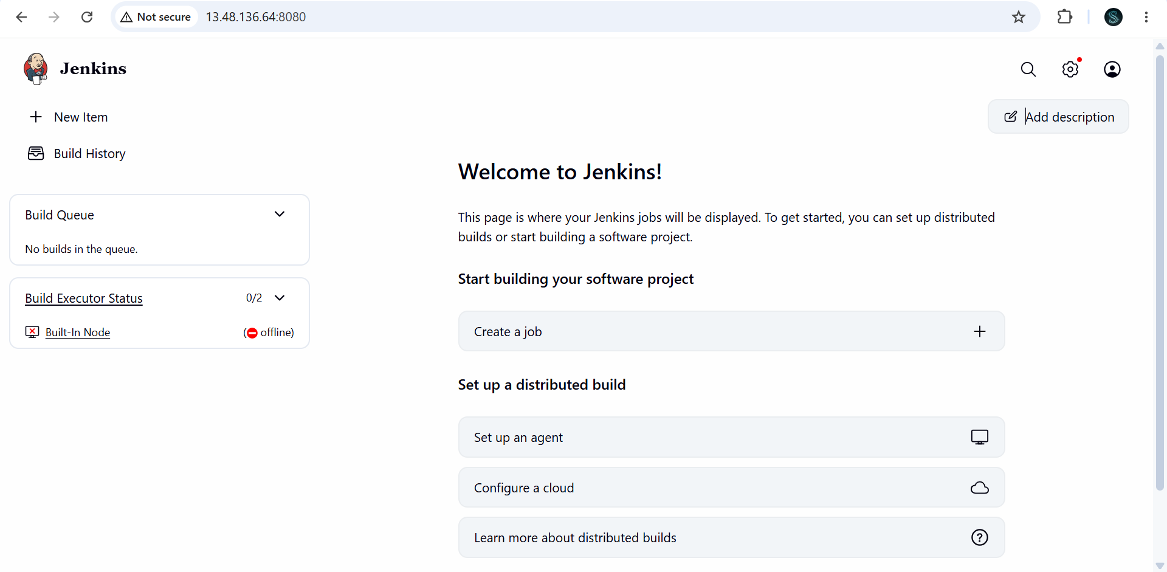

3. Install Apache
- Update the system - sudo dnf update -y
- Install Apache - sudo dnf install httpd -y
- Start Apache - sudo systemctl start httpd
- Enable Apache to start on boot - sudo systemctl enable httpd
- Check Apache status - sudo systemctl status httpd
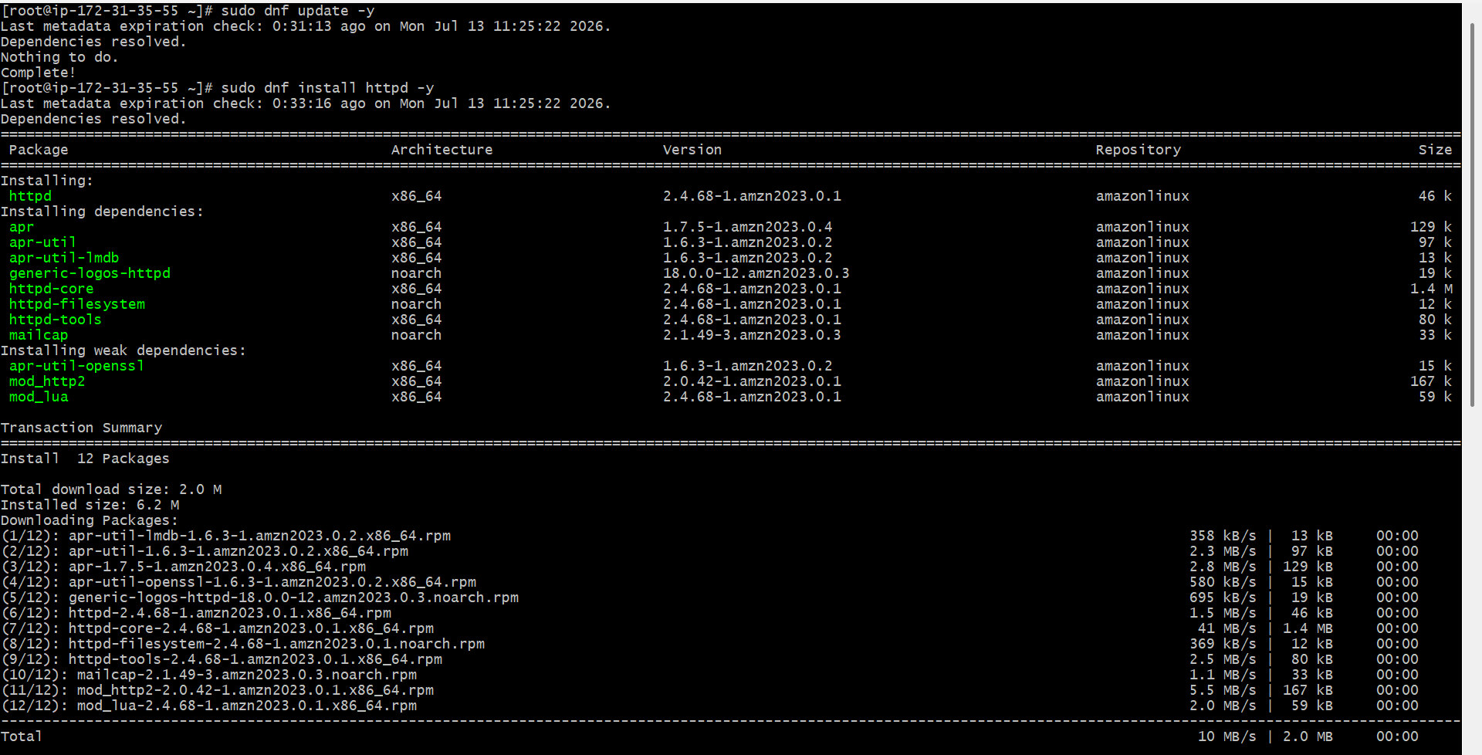
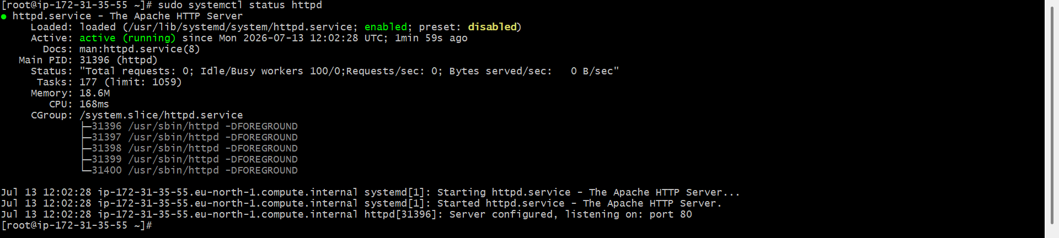

4. Install Nginx.
- Update the system - sudo dnf update -y
- Install Nginx - sudo dnf install nginx -y
- Start Nginx - sudo systemctl start nginx
- sudo systemctl enable nginx
- sudo systemctl status nginx
- Open http://13.48.136.64 on your browser
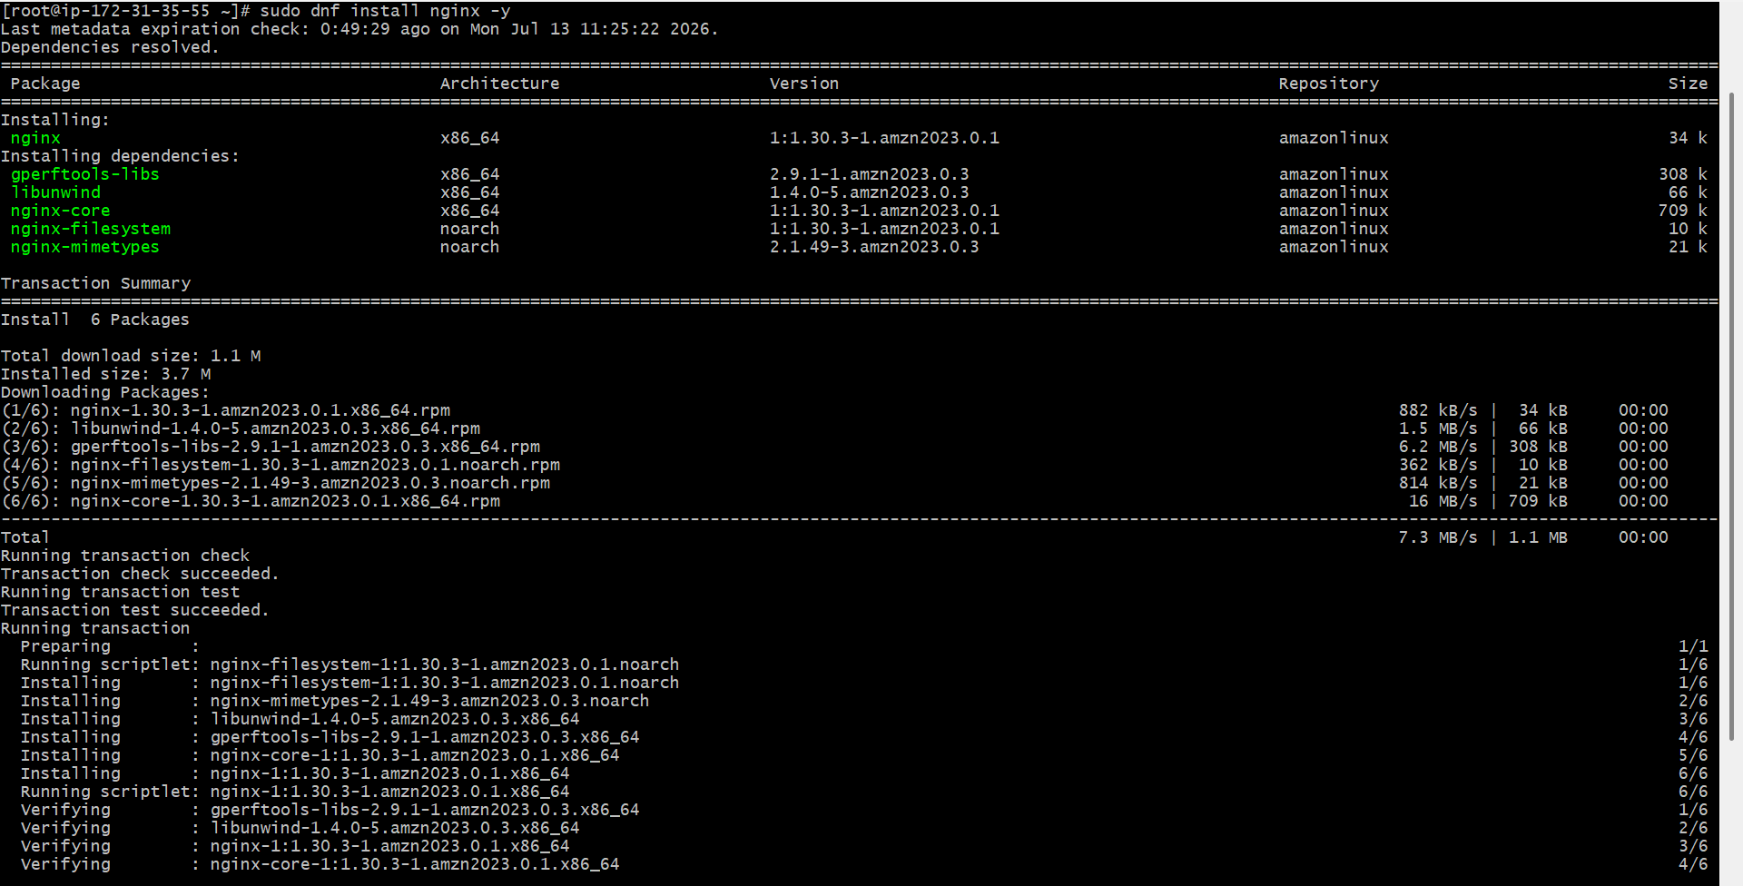
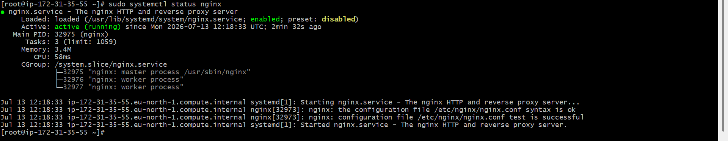
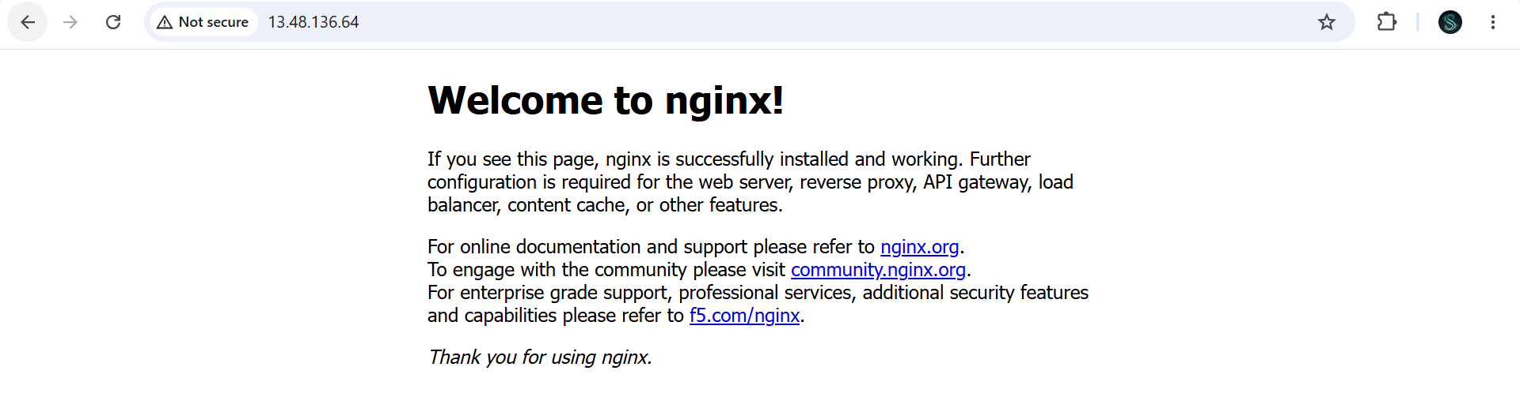
5. Install Apache Tomcat.
- Install Java
- sudo dnf install java-21-amazon-corretto -y
- java -version
- Download Tomcat
- Go to cd /opt
- Download the latest Tomcat
- sudo wget https://downloads.apache.org/tomcat/tomcat-10/v10.1.57/bin/apache-tomcat-10.1.57.tar.gz
- Extract the archive - sudo tar -xzf apache-tomcat-10.1.57.tar.gz
- ls -l
- Rename the directory - sudo mv apache-tomcat-10.1.57 tomcat
- Go to the Tomcat bin directory - cd /opt/tomcat/bin
- Give execute permission - sudo chmod +x *.sh
- Check if port 8080 is already in use - sudo ss -tulnp | grep 8080
- Start Tomcat - run ./startup.sh
- Open Tomcat in your browser - http://13.48.136.64:8080
